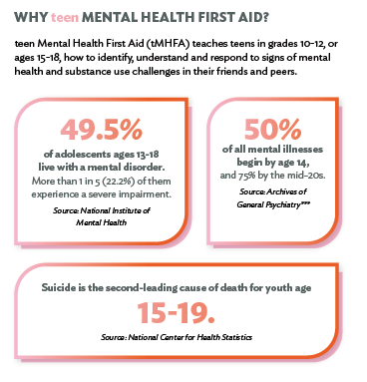
BENEFITS OF BRINGING tMHFA TO YOUR SCHOOL OR ORGANIZATION:
- Give young people the skills to identify and respond to mental health and substance use challenges, including how to seek the help of a responsible and trusted adult.
- Promote a healthy and happy environment that recognizes the value of physical and mental health.
- Empower teens to open the conversation about mental illnesses and addiction with friends.
- Address the impact of school violence and bullying on mental health.

AFTER THE COURSE TEENS WILL BE ABLE TO:
- Recognize early warning signs that a friend is developing a mental health or substance use challenge.
- Recognize warning signs that a friend may be experiencing a mental health or substance use crisis.
- Describe how to talk to a friend about mental health and seeking help.
- Explain when and how to get a responsible adult involved.
- Discuss where to find appropriate and helpful resources about mental health challenges and professional help.
- Apply the tMHFA Action Plan to help a friend with a mental health or substance use challenge or crisis.
Requirements to Bring tMHFA to Your School or Organization
To teach teen Mental Health First Aid (tMHFA) at your school or youth-serving organization, you must meet the following requirements:
- Must be able to implement tMHFA for teens in grades 10, 11, and/or 12, or ages 15-18. At this time, grade 9 and post-secondary students are not permitted.
- Must be able to meet the criteria of implementing tMHFA with fidelity: If teaching at a school, the course should be taught to an entire grade level of students (not individual classes) in the school. If teaching at a youth-serving organization or program, the course should be taught to an entire group of students at the youth-serving organization or program.
- Schools or organizations must have a minimum of 10% of staff at the site trained in YMHFA. This requirement is intended to ensure the capacity of staff members to adequately address any mental health and substance use challenges among teens.
- The school or organization offering the training must have a safety protocol in place to ensure youth safety, including how to respond to a teen who’s in distress and indicates they would like to be seen.
- The course should be taught in classes of approximately five to 30 teens on non-consecutive days. The program should not be taught in large, assembly-style sessions.
- Lessons are conducted in person in six 45-minute sessions or three 90-minute sessions.

For more information on bringing teen Mental Health First Aid training to your school or organization, contact:
Dodi Haug, Prevention Coordinator
NE Prevention Resource Center, Human Service Agency
(605) 884-3516
dodih@humanserviceagency.org

